**1** Pollution is a serious problem. It is often caused by waste gases, many released as the result of human activity. Name the gas or pollutant which is responsible for each of the following forms of air pollution.

**a)** Acid rain

**b)** Damage to the ozone layer

**c)** Smog

**d)** Global warming (4)

**2** Land pollution is increasing as humans throw away more and more. Land pollution could be reduced by recycling unwanted items.

**a)** What is the difference between recycling and re-using? (2)

**b)** Name three things that can be recycled. (2)

**c)** Landfill sites are used to dump materials that cannot be recycled or reused. What are the disadvantages of using landfill sites? (3)

**3** A food chain is a simple representation of feeding relationships. The organisms are found at different trophic levels.

**a) i)** Rearrange the food chain so the organisms are in the correct order.

Eagle → Cabbage → Sparrow → Caterpillar (2)

**ii)** What is meant by a trophic level? (1)

**iii)** What are the arrows in the food chain representing? (1)

**b)** Which organism in the food chain is:

**i)** a producer

**ii)** a herbivore

**iii)** the apex predator. (3)

**c)** Draw a pyramid of biomass for this food chain. (2)

**d)** Label each trophic level on the pyramid by placing the organisms in the correct place (1)

**e)** Explain the term biomass? (2)

**4** The table shows the daily food intake of four different species of mammal.

|  |  |  |  |
| --- | --- | --- | --- |
| Mammal | Body mass (g) | Mass of food eaten daily (g) | Amount eaten as % of body mass |
| Shrew | 10 | 30 |  |
| Mouse | 40 | 55 | 138 |
| Rat | 250 | 150 | 60 |
| Squirrel | 480 | 250 |  |

**a)** Calculate the mass of food eaten by the shrew and the squirrel as a percentage of their body mass. Put the figures in the table. (2)

**b)** Describe the trend shown in the amount of food eaten as a percentage of the body mass for these mammals. (2)

**c)** Which animal needs to spend the most time eating? (1)

**d)** Suggest an explanation for your answer to c) (2)

**5** To feed the growing number of people on the planet, farmers need to maximise the yield of the plants or animals they rear.

**a)** What is intensive farming? (2)

**b)** Intensive farming often involves growing a monoculture. What is a monoculture? (1)

**c)** Describe two disadvantages of a monoculture? (2)

**d)** Why is organic farming thought to be more beneficial than intensive farming? (3)

**6** Some food materials are created through biotechnological processes. An example of such a food is mycoprotein. It is created in a fermenter.

**a)** What is biotechnology? (1)

**b)** What is mycoprotein? (1)

The diagram shows a fermenter that can be used to produce mycoprotein.

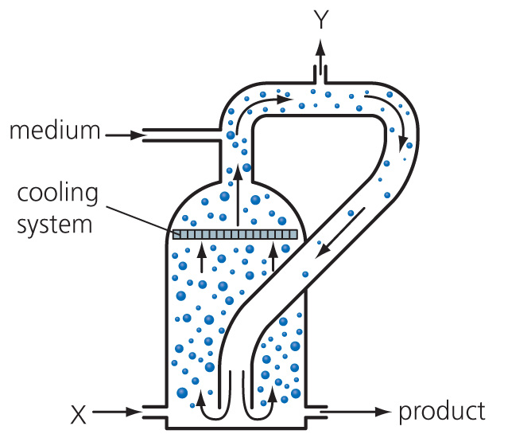

**c) i)** What is added as a source of food for the organisms in the fermenter? (1)

**ii)** What two substances are added at point X? (2)

**iii)** Give the specific role of each of these substances. (2)

**iv)** How are the contents of the fermenter mixed together? (1)

**v)** What is released at point Y? (1)

**d)** Describe the health benefits of eating mycoprotein? (3)

TOTAL = 50

**1 a)** sulfur dioxide

**b)** CFCs/chlorofluorocarbons

**c)** smoke/particulates

**d)** carbon dioxide (4)

**2 a)** Recycling is changing a waste product/waste material into a different, useful product. Re-using means to use again; re-use something for its original purpose, re-use something without changing it for another purpose. (2)

**b)** glass, paper, plastic, clothes, wood

(All 3 for 2 marks, 1 mark for 2. Maximum 2)

**c)** Landfill sites attract vermin like rats and mice. Vermin transmit diseases. Some items break down in landfill sites to produce toxic materials which leach into water. Heavy metals and toxic chemicals pollute local soil. Gases like methane can build up in landfill sites, which leads to global warming. (3)

**3** **a)** **i)** Cabbage → Caterpillar → Sparrow → Eagle (2)

**ii)** a feeding level (1)

**iii)** The direction in which the energy flows; the passage of food from one level  
to the next. (1)

**b)** **i)** cabbage

**ii)** caterpillar

**iii)** eagle (3)

**c)** and **d)**

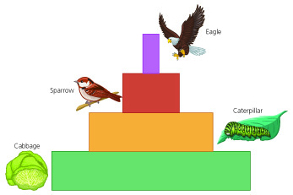

(1 mark for all 4 bars; 1 mark for the width of bars being correct = 2) (1 mark for all organisms in the correct box)

**e)** Biomass is the mass of biological material that can be passed on to the next trophic level; it is the amount of edible material at a trophic level. (2)

**4 a)**

|  |  |  |  |
| --- | --- | --- | --- |
| Mammal | Body mass (g) | Mass of food eaten daily (g) | Amount eaten as % of body mass |
| Shrew | 10 | 30 | **300** |
| Mouse | 40 | 55 | 138 |
| Rat | 250 | 150 | 60 |
| Squirrel | 480 | 250 | **52** |

(1 mark each = 2)

**b)** As the size of the organisms increases; the mass of food eaten as a % of body weight decreases. (2)

**c)** the shrew (1)

**d)** The shrew needs to eat 300% of its body mass in food daily; so will spend more time looking for food; it will waste energy from the food by moving; the shrew is the smallest and will lose most of the energy from the food as heat through its surface. (2)

**5** **a)** Using modern machinery or chemicals; to grow as much crop (or rear as many animals) as possible in the space available. (2)

**b)** One species of plant only is grown year after year in the same place. (1)

**c)** Plant removes the same nutrients from soil every year/soil damaged; lack of biodiversity; build up of pests. (2)

**d)** Farming using natural methods; natural fertilizers and pesticides use; less damaging to biodiversity in fields and hedgerows; fewer antibiotics given to animals; biological control methods used. (3)

**6 a)** Using living organisms to make useful products. (1)

**b)** Protein food made by fungi; fungus that can be made in huge quantities; protein food made under trademark Quorn. (1)

**c)** **i)** glucose (1)

**ii)** air and ammonia (2)

**iii)** Air to allow aerobic respiration; ammonia as a source of nitrogen for the creation of protein. (2)

**iv)** Circulating air lifts the mixture upwards so it can circulate and mix. (1)

**v)** Gases released; pressure release. (1)

**d)** Low in saturated fats; low in cholesterol; high in protein; meat free so suitable for vegetarians; high in fibre. (3)

TOTAL = 50